**Maths and the making of the modern and future world.**

**Lecture Two: The mathematics of climate change.**

**Chris Budd OBE, University of Bath, UK**

**Gresham Professor of Geometry**

November 13th, 2018

1. **Introduction**

Without question, climate change, and its effects on the environment and on society, is one of the most important, and controversial, issues facing all of us at the current time. It raises high passions on all sides of the media and of the political spectrum. Whilst most scientists believe that there is good evidence for human influenced climate change, there is by no means 100% agreement as to either its importance or of the impact in the future. It is noticeable that Gresham College itself thinks the field is of sufficient importance to have its own Professor of the Environment, Prof. Jacqueline McGlade. Hugely important questions remain such as. Is climate change happening? If it is happening is it due to human or natural causes? Will the effect of climate change be positive or negative? If there are negative effects and they are due to human causes, can anything be done about them, or are we past the point of no return?

In this lecture I will be concentrating on the mathematical aspects of these questions. In particular I will explaining what mathematical techniques, including such areas as mathematical modelling, probability, statistics, dynamical systems theory and scientific computing, can be brought to bear to clarify our current understanding and make predictions for the future, qualified by clear measures of uncertainty. An important reason for doing this, is that many of the current predictions, which are used by bodies such as the Intergovernmental Panel for Climate Change (the IPCC), are based on huge computer models.

Indeed the IPCC has just released a new report [1] based on these predictions. It is these models which have also led to the 2016 Paris Agreement [2], that we should restrict our CO2 emissions in such a way to keep the Earth’s temperature rise to below 1.5 degrees Centigrade. These complex models are, in turn, based on mathematical formulations of the physics governing the climate, informed by statistical measurements of the existing climate. Thus to have an informed debate about the future of the climate of this planet, the public has a right to know how these models are constructed, how they are tested, what sort of predictions they make, and (crucially) how reliable are their predictions? In fact climate models are the most certain (or the least uncertain) of a whole set of models used to determine the effect of the climate on human beings. I illustrate these below. For this lecture I will talk about the blue part of this figure. For the rest see the fourth lecture in this series when I talk about Future Cities

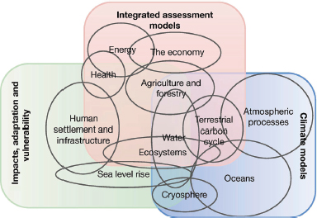

Without question weather has a huge affect on us all, and if weather patterns are changing due to climate variation then we need to take this seriously. The effect of climate change on society and on the environment is well addressed in the lectures this year by the Gresham Professor of the Environment, so I will not go into any detail here. But I cannot resist telling you a story from my own experience. About a year ago I organised a seminar at my home institution of the University of Bath. The seminar was to have been given by an expert from the Met Office and her subject was ‘The effect of extreme weather on the transport network’. On the morning of the seminar she ran me up. Owing to the effect of severe weather on the transport network the trains between Exeter and Bath were not running, so she could not make it in! How I enjoyed sending the email explaining why the seminar was cancelled (and the wonderful responses that I received), it made the point better than actually giving the seminar itself. (I should say that later in the year we did have the seminar, and it was excellent).

I will start this lecture by looking at evidence for climate change, both in the past and in the present. I will then describe the way that (mathematical) climate models work and show how these can make predictions with quantifiable uncertainty. Then I will finish by asking the (again mathematical) question of whether the climate has reached a tipping point. Anyone interested in the broader issues of environmental change, its implications on society, and the changes that we need to make in view of the predictions of climate change, should go to the future Gresham lectures by Prof. McGlade. A very readable account of the issues related to climate change is given in the Ladybird book [3].

1. **What is the evidence for climate change?**
   1. **Current changes in the climate**

There is a lot of incontrovertible statistical evidence that the current climate is changing, even if the reasons for this change and the significance of it, are the subject of hot debate. This evidence can, in turn, be used as a test of our climate change models. I will now look at four examples of this taken from the physical world, which can be measured directly and also checked in the climate models I will describe later.

*A. Global Warming*

According to the IPCC *5th Assessment Report WG1 -­ Science Basis “Warming of the climate system is unequivocal, and since the 1950s, many of the observed changes are unprecedented over decades to millennia.”* [4]

So, let’s look at the actual evidence for this. Recent records on the Earth’s temperature come from a variety of different sources including weather stations on the Earth’s surface, satellites orbiting the Earth, and buoys and ships in the ocean. In the case of the weather stations, these records have been gathered reliably since the foundation of the Met Office in 1850. A graph of these is given below up to 2017, in which we show the Earth’s average temperature each year, compared to the 1951-1980 average temperature.

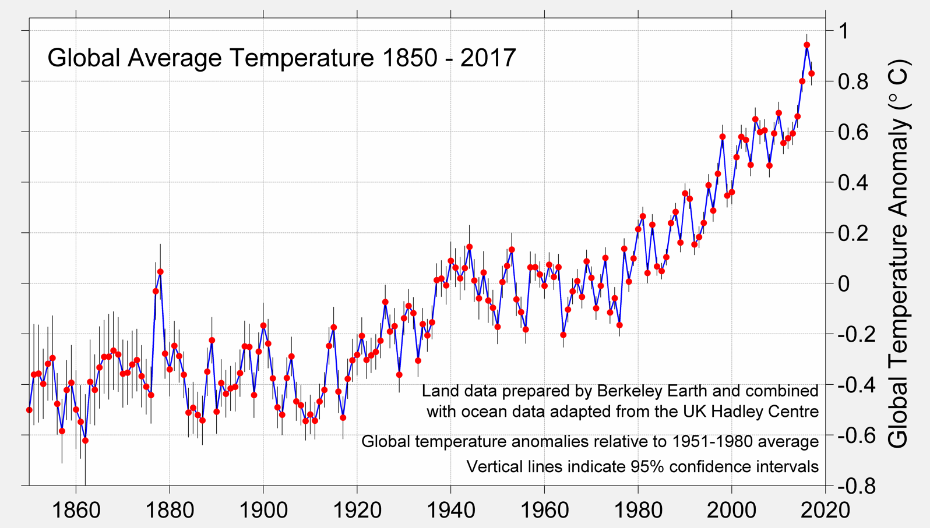

In this period the average temperature of the Earth has gone up and down from year to year, due to such factors as the El Nino (a warming of the Southern Pacific ocean due to the effect of ocean currents), other ocean current related effects, and also large volcanic eruptions such as Krakatoa in 1883. However these variations are superimposed on a trend, which is clearly rising. Indeed in 2015 the Earth was on average 1 degree Centigrade warmer than it was when these records began, and the last three decades have been the warmest ever recorded.

*B. Loss of ice and sea level rise*

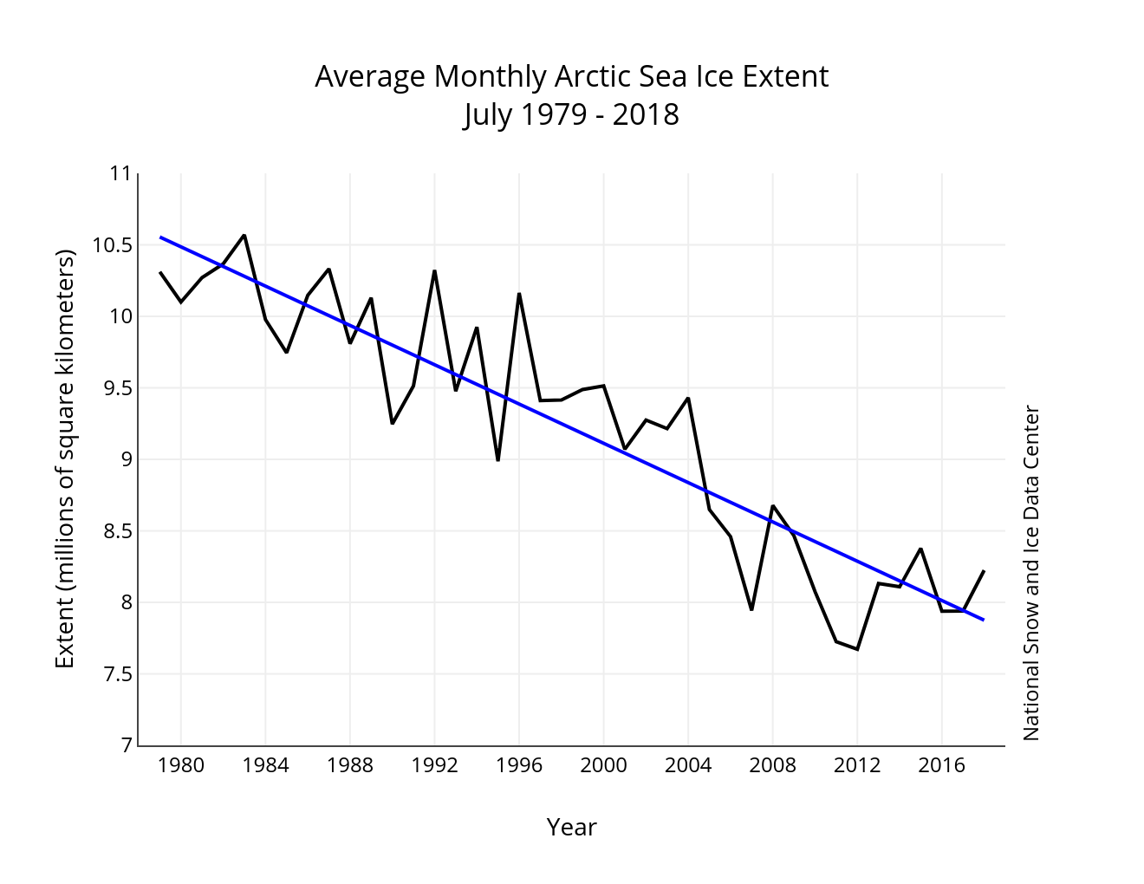A direct consequence of global warming, and one of the clearest indications of its impact, has been the loss of the Arctic Sea Ice. Clear evidence of this is available from the NASA National Snow and Ice Data Center satellite, which has monitored the extent of the summer sea ice since 1979. The resulting graph, below shows a very clear trend downwards (indicated by the blue line)

In 36 years approximately 2.5 million square kilometres of summer sea ice have been lost. This is equivalent to the area of Scotland every year. If this rate of loss continues, all of the Arctic sea ice will have vanished in 100 years. At the same time land ice has been lost from both Antarctica and the ice sheets on Greenland

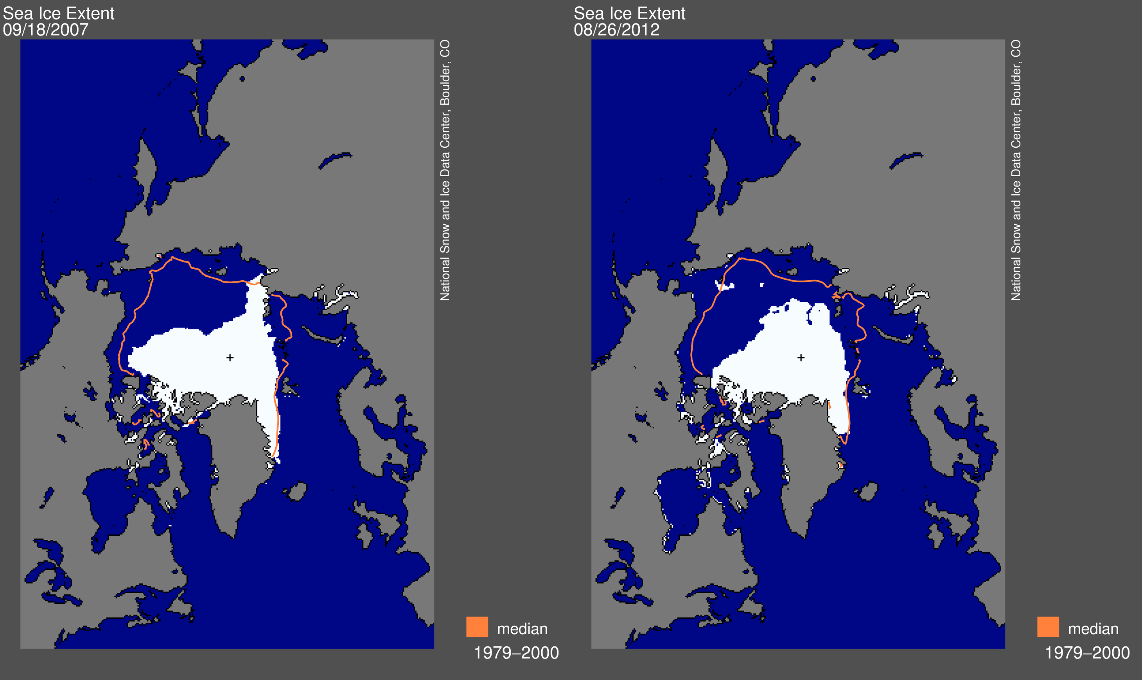

There are a number of consequences of this. The one we most hear about is the loss of habitat for such animals as the polar bears. A second consequence is a change in the salinity of the Atlantic Ocean due to the addition of the fresh water from the melting ice. This could, in the long term, have a direct influence on the ocean circulation patterns, including a shift in the direction of the North Atlantic Drift, which keeps the UK warm. (So ironically global warming at the North Pole could possibly make the UK colder.) A third long term consequence is that the Earth gets darker. One of the functions of the ice sheets is that they reflect a large amount of the Sun’s energy and keep us cooler as a result. Thus, as the ice sheets retreat so we will warm up. I will return to this topic later when we look at tipping points.

A more immediate, and observable consequence, of the melting ice, and also one, which will have significant impact on humanity, is the rise in the average sea level. There are two reasons for this. Firstly the melting of the land (but not the sea) ice adds to the volume of the water in the oceans. Secondly, as the ocean temperature increases due to global warming (as described above), so its volume increases due to the effects of thermal expansion. The increase in sea level can be measured using tide gauges and more recently by radar from orbiting satellites. This is shown below.

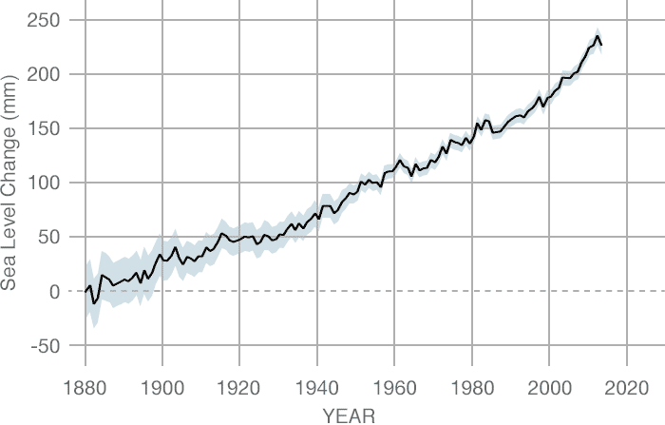

The main worry about sea level rise is the impact that it will have on low lying coastal areas, especially when compounded with storm surges and other effects of events such as hurricanes. Sustained sea level rise will make many of the worlds cities and coastal regions very vulnerable.

*C. Increases in the number of extreme events*

You have probably noticed that there have been a lot of big storms recently. For example the major wind and rain storms in the UK, including the St Valentine’s Day storm in 2014 illustrated below.

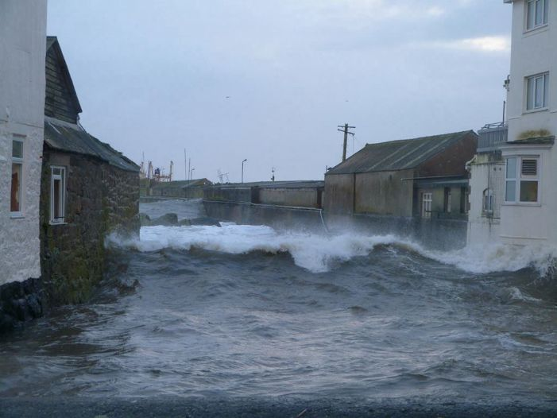

Other recent extreme events have included the 2003 heat wave, which killed thousands of people, the severe hurricanes affecting the USA since the start of the 21st Century, and extensive flooding in Pakistan. Is this evidence for climate change? The answer is almost certainly YES, but to understand why we need to understand a bit about statistics. We saw above how the average temperature of the Earth has increased by one degree Centigrade since records began. This may not seem very much, after all the daily temperature variation is much more than this. However this shift in the mean temperature significantly increases the likelihood of extreme temperatures, and related events such as higher rainfall (as a warmer atmosphere can hold more water). To see this, have a look at the graph below.

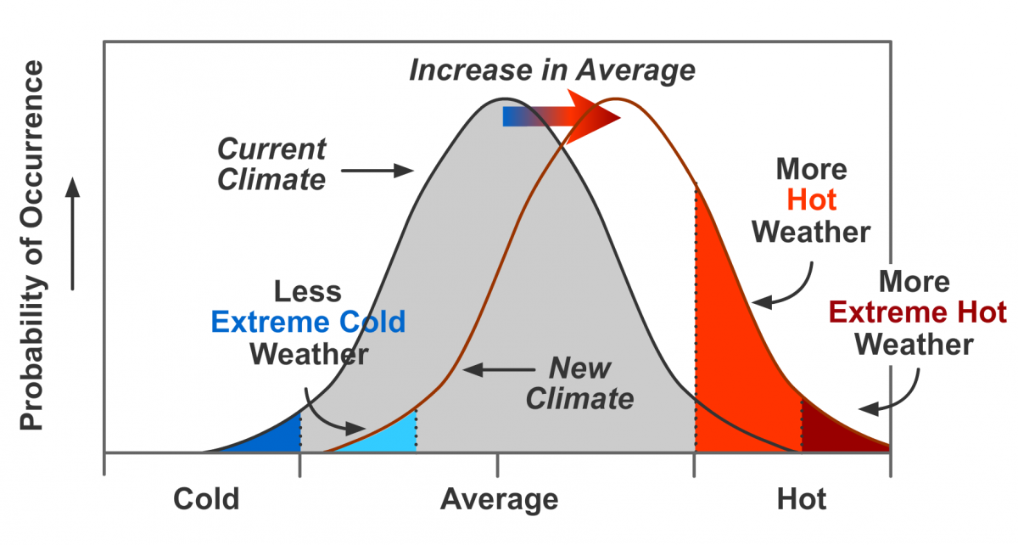

The graph on the left shows a typical statistical distribution of temperatures, which is a Bell Curve centred on the mean. The portion on the far right is the tail of the distribution and the area under the tail shows the probability of a hot temperature. The curve on the right shows what happens if the average temperature increases. This has the effect of shifting the whole bell curve to the right. The consequence on the chance of high and extreme weather is profound. The small shift to the right raises the height of the curve in the tail by a very large amount. This in turn dramatically increases the chance of having extreme weather events. A graph below of the increase in extreme temperature events is consistent with this prediction as is the increased frequency of tropical storms.

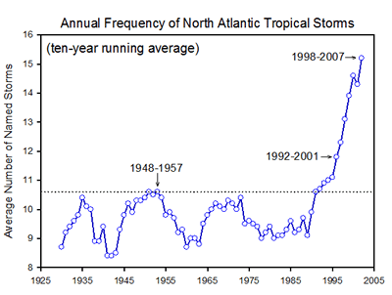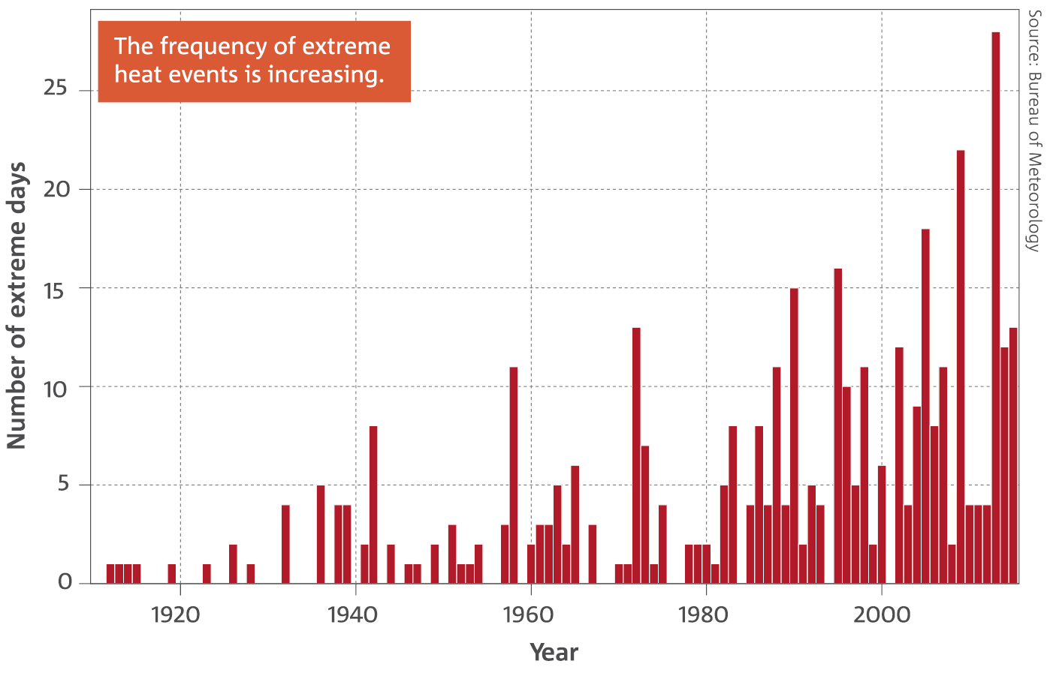

*D. Carbon Dioxide Increases*

It is possible to monitor the amount of Carbon Dioxide in the atmosphere with high precision. For example the Mauna Loa observatory in Hawaii takes daily measurements of the amount of Carbon Dioxide in parts per million (ppm) in the atmosphere. The disturbing results of these measurements are shown below in what is called a Keeling Curve.

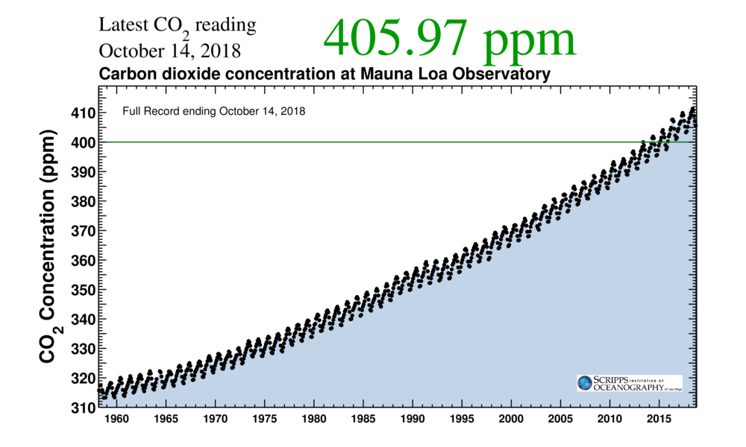

The Carbon Dioxide levels vary up and down during the course of a year owing to seasonal changes. However, the overall trend is one of rapid increase. Indeed in the last fifty years the average amount of Carbon Dioxide has risen from 320 ppm to the current value of 406 ppm. This fact is undeniable, and is almost certainly due to the burning of fossil fuels such as oil, coal and gas. However it is the impact of the Carbon Dioxide rise on the Earth’s temperature which leads to a lot of controversy and is at the heart of the IPCCs recommendations on the need for a ‘low Carbon economy’. The key question is whether the increase in Carbon Dioxide levels leads to a temperature increase (due to the ‘Greenhouse Effect’), or conversely whether it is a rise in temperature (say due to natural causes), which has led to an increase in Carbon Dioxide levels. If it is the former then we need to do something to stop a climate disaster. In the latter, we are just the victims of natural climate variations and cannot do anything about it. Later in this lecture I will show how mathematical models of climate are consistent with the first viewpoint and not with the second. It is also worth saying that as a test of some of the most sophisticated climate models the climate was set to that at the beginning of the 20th Century and the models asked to ‘predict’ the last 100 years of the Earth’s climate. Two scenarios were chosen, one in which the Carbon Dioxide levels were set to the measured values and the other in which they were kept at the same value that they had in 1900. This process is called *hind-casting*. Suffice to say the hind-casts with the observed Carbon Dioxide levels correctly reproduced the variations in the Earth’s temperature, whilst those with the constant Carbon Dioxide levels, predicted much lower temperatures.

**2.2 Past climate changes**

A common criticism (see for example various speeches by the US President Donald Trump) of the above evidence for climate change is that it is simply natural and not caused by human action. To a certain extent he is correct in that there is no question at all that the climate has changed in the past, and in ways that human beings could not have been responsible for. For example about 400 years ago we were experiencing a ‘little ice age’ when temperatures were noticeably cooler than today, and then the Earth gradually warmed up. There is also clear evidence that millions, if not billions of years ago, the Earth has gone through periods of being very cold, and also of being very hot. A further criticism of the recommendations of the IPCC is that the Earth will naturally regulate its climate as it has done in the past, and that it will do so in the future. However both of these criticisms fail. In the first case, as we shall see, the observed changes in climate are the opposite of what we would expect from extrapolations of the historical. In the second case, the changes that we are currently seeing are far more rapid than any such changes in the past. It is most unclear whether the Earth’s recovery mechanisms can react fast enough to counter the effects of these. I will return to this topic later in this lecture.

Modern climate records taking direct measurements of temperature, rainfall, ice cover, and other climate indicators, really only started when the Met Office was founded in the UK. In paleo-climatology, or the study of past climates, scientists use proxy data to reconstruct past climate conditions. Proxy data are preserved physical characteristics of the environment that stand in for direct measurements. Paleo-climate scientists gather proxy data from natural recorders of climate variability such as tree rings, ice cores, bore holes, fossil pollen, ocean sediments, corals and historical data (such as the French grape harvest). By analysing records taken from these and other proxy sources, climate scientists can extend our understanding of climate well beyond the instrumental record. One of the most important of these proxy measurements is the Oxygen-18 isotope. Oxygen occurs in the Earth’s atmosphere in various isotope forms. Most of it is the Oxygen-16 isotope, but a smaller amount is the heavier Oxygen-18 isotope. The ratio between the Oxygen-16 and Oxygen-18 water molecules in an ice core, helps to determine past temperatures and snow cover. The heavier Oxygen-18 isotope condenses more readily as temperatures decrease and falls more easily as rain or snow, while the lighter Oxygen-16 isotope needs colder conditions to precipitate.

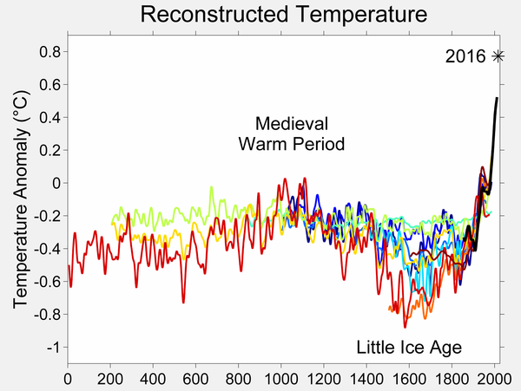

The temperature over the last 2000 years as estimated by various proxies is illustrated above

Different proxies lead to slightly different reconstructions, but the overall pattern is clear. We see a gradual cooling resulting in the Little Ice Age, followed by a very rapid warming as we approach the present day. By drilling deep into the Antarctic ice, and measuring the Oxygen we can find out the temperatures of the past million or so years. The results are presented below and are remarkable. In this famous figure the

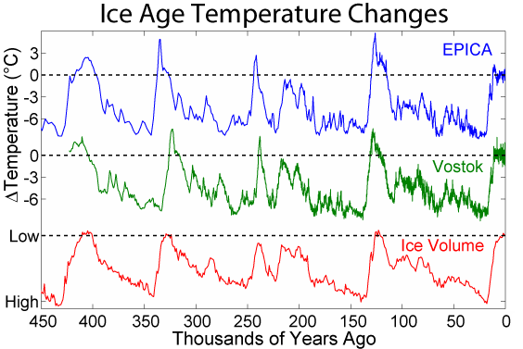

top two graphs show the temperature over the last 450 thousand years, as estimated from two different ice core samples called EPICA and Vostok. The lowest graph shows the estimated volume of the ice covering the Earth over the same time period. This figure shows clear evidence for four complete ice ages. In a typical glacial cycle the Earth gradually cools and the ice volume increases. The ice age then ends in a rapid warming period. The most recent such period was the end of the younger Dryas ice age about 10,000 years ago. This of course led to the modern age, in particular the start of agriculture and the growth of civilisation. What I find remarkable about this graph is its regular periodic behaviour. In particular we see ice ages, with large variations in temperature appearing, almost by clockwork, every 100,000 years. What is also interesting is that as we go further back in time this cycle changes and is replaced by much smaller changes in temperature every 40,000 years. We will have a look at what causes the ice ages later in this lecture. But one prediction from this regular graph is very clear. If nature was left to itself then we should be entering the cooling phase of the next ice age. Instead, things are getting warmer.

A plot of the historical values of Carbon Dioxide, given below, is equally striking. Again we can see natural cycles in the Carbon Dioxide levels between 180 ppm and 300 ppm, which are in synchrony with the temperature and ice cover variations. However as we approach the present day, and in particular since the start of the industrial revolution, the Carbon Dioxide levels have increased extremely rapidly to the current value of over 400 ppm. This man made rise is far more rapid than any natural variation.



1. **How do we model climate change?**
   1. How are climate models derived

As I said in my last lecture, it is hard to predict anything, especially in the future. Climate change is no exception to this. There are various reasons. The climate is very complex, it is hard to get good data (especially of the initial states), the equations for climate are hard to solve and may have multiple solutions, chaotic behaviour is always present, and it can be hard to distinguish natural effects from human intervention. This is what a careful mathematical approach is essential if we are to construct climate models with any degree of reliability.

Climate change models are complex and large. If we link them to models of the effect of climate change on the economy and society then they get even more complex! Such models have millions, if not billions, of lines of computer code in them. So, how are the models constructed, tested and do we believe them.

**All climate models start from the laws of physics.**

These laws have been carefully tested and validated over centuries. Most climate models also are based on weather prediction codes, which are tested every day! Basically the climate that we see arises from the interaction of the energy coming from the sun with the atmosphere, the oceans, the ice and the vegetation.

The basic laws of physics for *weather forecasting* are the Navier-Stokes partial differential equations of fluid motion on a rotating sphere (which describe the evolution of the momentum and energy of the air and the oceans), which are coupled to the laws of Thermodynamics (which describe the evolution of the temperature, and the effect of heat on from the Sun on air, water and water vapour). Together these equations are:



These equations for the weather are solved every six hours by the Met Office, to produce a five day weather forecast. They are, however, much too complicated to solve by hand. Instead we solve them by using a computer. The first idea of doing this came from L F Richardson and his envisaged computer was a room full of students. His idea was to divide up the Earth, and its atmosphere and oceans, into a large number of small cubes.

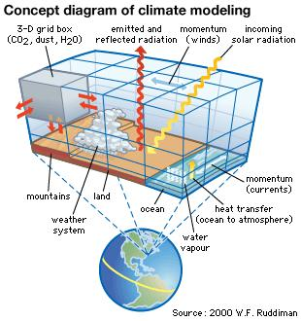

The equations of the weather are then approximated over each cube in a procedure called discretisation. For the UK forecast each such cube has a size of about 1.5 km on each side. In a typical forecast there are about a billion such discrete equations. To solve them involves inverting very large matrices and such a calculation takes about one hour on a super computer. To see more I recommend the website [5]. An image from this given below in which we see both the weather map and further information on temperature, precipitation etc.

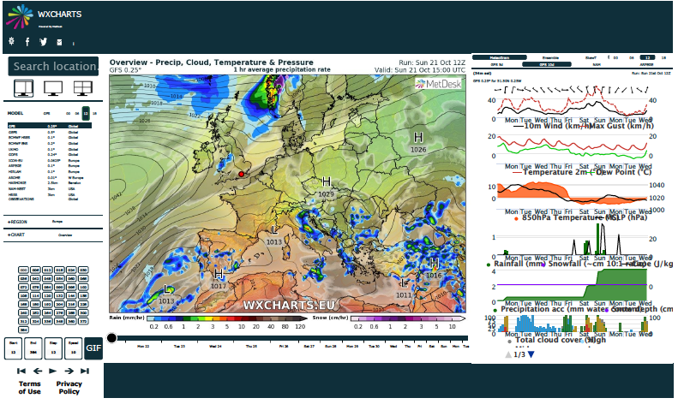

To see how the climate evolves we have to augment these equations. This process is hard for a number of reasons. *Firstly*, to predict climate changes we have to forecast many years ahead (sometimes thousands or millions of years). *Secondly* we have to include a lot of extra physics, chemistry and even biology. This includes ocean currents, sea ice, land ice, solar physics, complex atmospheric chemistry, vegetation (on both land and in the ocean), animals, clouds, permafrost, and greenhouse gases. *Thirdly*, the systems we are looking at in climate modelling are very nonlinear and may well have chaotic solutions, as I described in my last lecture. *Finally* (and most uncertainly) we have to account for the current, and future impact of humanity, including such effects as the changes amount of Carbon Dioxide in the atmosphere as the result of the burning of fossil fuels, changes in farming practices or of cutting down the rain forests. Because of the size and complexity of the resulting systems it is hard to check them, change them and to run them. It is also hard to interpret the results as they produce a mass of data (a billion data points for each forecast) which is hard to analyse and even hard to store.

* 1. What sort of models do we then use?

*Climate is what you expect, and weather is what you actually get.*

Climate models have been evolving considerably over the last decades, both in accuracy and in complexity. They evolve in parallel both with faster computers and also improved mathematical models (this is where I do much of my own research [6]). The figure below shows how they have developed in complexity over the last 40 years.

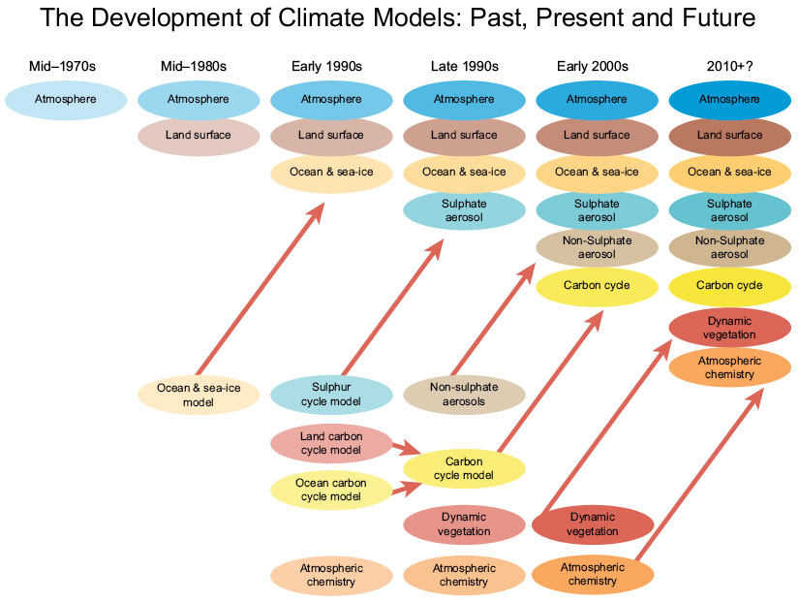

However in order to use and to run, a climate model certain approximations have to be made in comparison to a weather model. This is needed because, as we have seen climate models are much more complex than weather models. Furthermore, instead of looking five days into the future, a climate model must look decades, or even centuries, into the future. For this to be possible the spatial resolution of a climate model is much coarser than in a weather forecast. For example the cubes for the discretisation may be 100 km wide or more. Also the time steps are longer, and often the models look to find averaged quantities. There is a trade off in the amount of spatial resolution against the length of time that these models can predict into the future, and the different codes used by the Met Office are illustrated below.

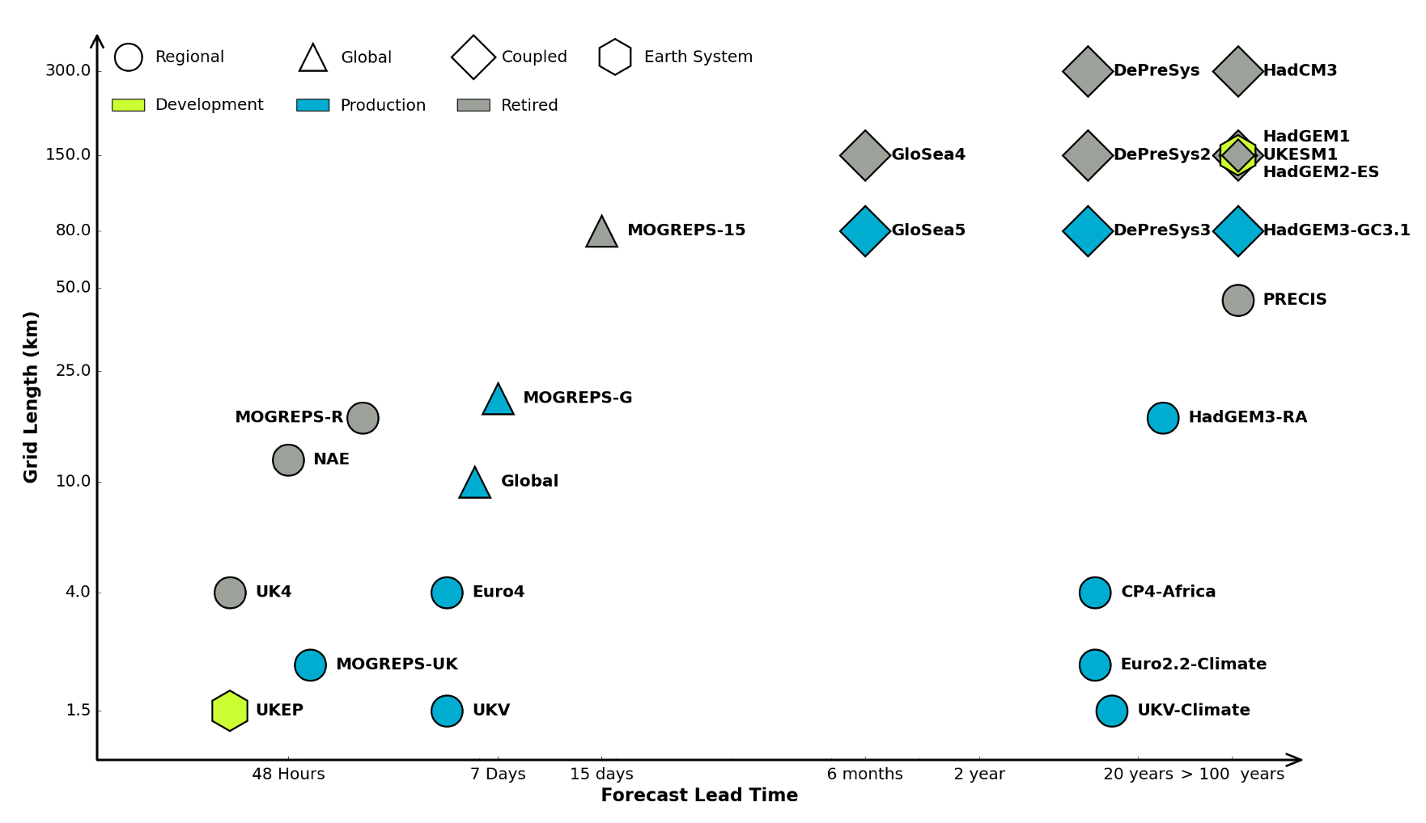

In this picture we can see the difference in application between a local weather forecasting code such as UK4, and a global climate model (GCM) such as HADGEM3-RA

3.3 How are the models tested? Global Climate Model (GCM) is a very complex piece of software with many millions of lines of code. Errors can arise in the way that the physics is represented, the algorithms used to solve that physics, the coding up of those algorithms, the data that is fed in to the calculation and the initial conditions used to start the whole system off. Because the climate models are based on weather models, one aspect of the testing is always available. Indeed, weather models are tested by comparing them against reality every six hours. A modern weather forecast updates its prediction constantly by comparing its predictions against data in a process called *data assimilation* [6]. Any systematic error in the code would quickly reveal itself in this process. A second check is that through mathematical arguments we can check the convergence of the algorithms used through the methods of *numerical analysis.* Thirdly, all modern climate algorithms assume that they are working with uncertain data. By using techniques from probability and statistics it is now possible to quantify this uncertainty so that we have a reasonable idea how accurate our forecasts may be. In particular we can build in uncertainty due to the model, the initial conditions and the ‘scenario’ (estimates of future human activity for example). A further way of testing a particular climate model is to compare it with the predictions of different models. There are many different climate centres worldwide. These use models which differ in the way they approximate the physics, the way they solve the resulting partial differential equations (for example by using a finite volume or a spectral method), and the various assumptions of human activity. Such centres include NCAR in the USA, the Hadley Centre in the UK, CSIRO in Australia, and CCSR in Japan. On the left we see the Hadley Centre predictions for the UK temperature with associated uncertainty, and on the right the predictions of global temperature using these various models (with the US predicting the lowest, the Japanese the highest and the UK in the middle).

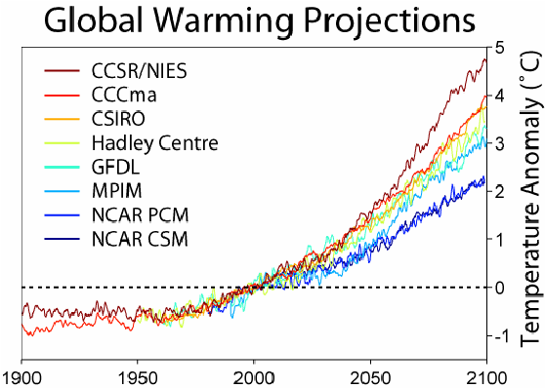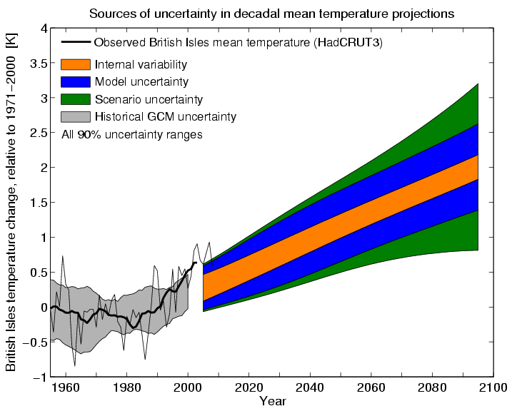

Unlike weather forecasts it is impossible to test a climate forecast directly against future data unless we are prepared to wait decades for the result. Instead we test them against past data using the hind casting method I described earlier over the 150 years for which we have reliable climate data. Essentially if a climate model can predict the past, then we have a good cause to believe that it can predict the future.

1. **Some ‘simple’ mathematical models of climate. What are they and what do they predict?**

There are several problems with using the GCM climate models preferred by the IPCC. The first is that their sheer size makes them very expensive to run, and the computers running them use a lot of energy in the process. For example the Met Office Cray XC40 supercomputer makes 14,000 trillion arithmetic operations per second, and uses 2.7 MegaWatts of power when it is running. It is indeed one of the ironies of modern climate science, that the computers doing the calculations contribute, by doing them, to global warming. They also take a long time to run, so that it can take days to get a forecast of the climate in 100 years. To get an estimate of the climate in a million years is quite impossible with a GCM. Thirdly, it is hard to do ‘what if’ experiments, in which we look at the effect of changing different parts of the model (such as the amount of greenhouse gases). Finally (and crucially for someone like me) the models are much to complex to be analysed by hand, so whilst we may be able to predict things, it is very hard to explain why we are seeing what we see. To address this we work with a hierarchy of different models of increasing complexity. At the simplest level are energy balance models (EBMs), next level up are Box Models which divide the Earth up into a number of large boxes, next come Earth Intermediate Complexity models (EMICS) or Reduced Climate Models (RCMs), then there are the (atmosphere and ocean) GCMs described above, these in turn are part of very complex Earth System Models (ESMs).

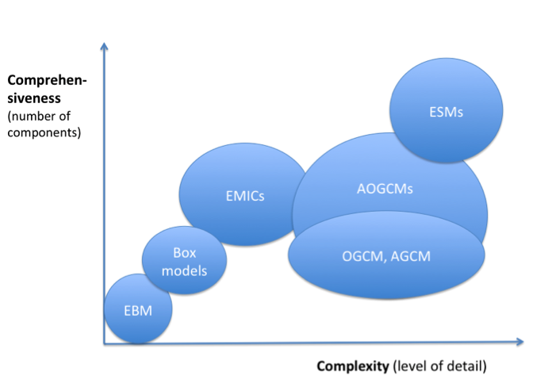

* 1. **Energy balance models (EBMs)**

The simplest of all of these models (and yet still with a good degree of predictability) are Energy Balance Models (EBMs). Whilst this model is really simple (indeed it can be implemented in ExCel) it can be used to inform us in the implementation of the 2016 Paris Agreement to keep the Earth’s temperature to below 1.5 Degrees Centigrade, and even to find the mean temperature of the Moon.

In an EBM the assumption is that the energy received by the Earth from the Sun is balanced by the energy radiated from the Earth back into space. The whole Earth is assumed to be at a single averaged temperature T and to behave as though it was one body being heated up by the Sun and releasing its energy back into space. In this model we take S(t) to be the radiation from the Sun which is primarily as short wavelength radiation. A proportion a S is reflected back by the Earth, where a is the Albedo. If a = 1 then all of the radiation is reflected, and if a = 0 then none of it is. So the total radiation reaching the Earth’s surface is (1-a) S. This radiation heats up the Earth, which in turn re-radiates it back into space as long wavelength radiation (infra-red). The amount of this radiation is given by the black body radiation law, in which the radiation is proportional to the fourth power of the absolute Temperature. Not all of the radiation from the Earth goes back into space. Indeed a significant proportion of it is absorbed in the atmosphere and reflected back to Earth. This absorption is the result of the Green House gases in the atmosphere, such as Carbon Dioxide, Methane and water vapour. As a result a proportion e of the radiated energy goes back onto space. Here e is the emissivity of the atmosphere which is 1 when there is no atmosphere, such as on the Moon, and is currently about 0.605 on the Earth. The various forms of radiation and re-radiation is illustrated below.

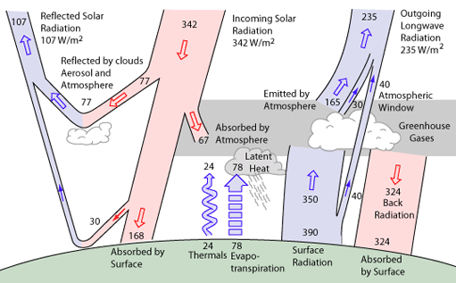

The difference between the incoming and outgoing radiation leads to a rate of change dT/dt in the temperature of the Earth, which is given by the equation.



Here are all known constants. If we assume that the Earth’s climate is in a steady state then we can set dT/dt = 0. We can then solve the above equation to give



We call this the *energy budget equation*. We can make a quick check of this formula. The current mean amount of solar heating on the Earth (allowing for variations in time and space) is



Similarly, the current accepted values of the constants on the Earth are a = 0.31, e = 0.605 and the Boltzmann constant

Substituting these values gives a mean absolute temperature of the Earth of T = 288K, which is about right. On the Moon we have e = 1. For the same values of the other constants we can predict a mean temperature of 254K. Which is again about right (although, due to its slow rotation, the temperature of the Moon is very different on the side which faces the Sun from that which is in darkness.)

Having made these checks, we can use the same formula to predict possible future climate change. Most significantly, if the emissivity e *decreases* then the temperature T *increases*. It is this prediction which gives us a direct link between Carbon Dioxide levels and the Earth’s temperature. It is a scientific fact that the emissivity of the atmosphere depends directly on the composition of the Greenhouse gases in it. Carbon Dioxide is one of these and the level of Carbon Dioxide contributes to the emissivity (alongside that due to water and Methane). A table of the calculated emissivity due to Carbon Dioxide alone is given below. The conclusions from this table are unambiguous. As the level of Carbon Dioxide *increases* so the emissivity *decreases*, and hence the temperature *increases.* Thus the huge increases in the levels of Carbon Dioxide in recent years are, according to this model, a clear contribution to global warming.

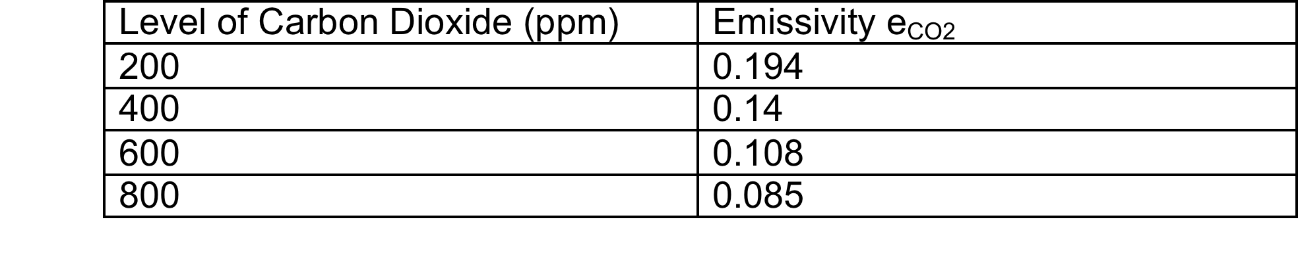

It is worth saying that similar predictions can be made for the effect of the increase in Methane levels, which increase both due to modern agriculture (in particular farm animals) and the melting of the Arctic permafrost.

Using this model we can start to consider the issues related to the Paris Agreement. The **Equilibrium Climate Sensitivity (ECS)** is the global mean surface warming necessary to balance the planetary energy budget after a doubling of atmospheric Carbon Dioxide. If W = S(1-a) is the total amount of energy reaching the Earth, then



It is estimated that doubling atmospheric Carbon Dioxide has the effect of changing W by about 4 W per metre squared. From the above this would indicate a rise in temperature of 1.2K, which is below the required 1.5K. This might lead to grounds for optimism. However the climate is more sensitive than this simple model implies because there are other feedback mechanisms in the climate we have not considered in the simple model. A significant one of these is the effects of ice melting, which we will look at presently

* 1. Predicting the Ice Ages

One of the most intriguing questions in climate change is what causes the ice ages. As we have seen the ice ages occur roughly once every 100,000 years and predicting them is important in helping us to understand what the climate will do in the next 1000 years. Despite many years of trying we are still very far from understanding what causes the ice ages and why they have such a regular period. A popular theory [7] is that they are caused by wobbles in the Earth’s audience (so called Milankovitch cycles). However, this neither predicts the period correctly or explains why about 750,000 years ago the frequency of the ice ages changed from 40,000 years to 100,000 years, the so called Mid Pleistocene Transition (MPT). Predicting the ice ages over such a long period is well beyond the capabilities of a GCM and hence they must be studied using a simpler model such as a box model. Indeed, predicting the ice ages requires a model which is more sophisticated than an energy balance model and less sophisticated than a GCM, but which. Doing this illustrates one of the main hazards of climate modelling. There are many possible simplifications of the full climate model, and there is far from a consensus as to which one should be used to predict the ice ages. In my own research I have counted over 30 so far. See [8] for more details. A model that I am currently studying, together with my PhD student Susan Morupisi, combines the Milankovitch cycles with the assumption that Carbon Dioxide is stored in the oceans, and is released when it gets to a critical value. This model both predicts the right period and the MPT so I am hopeful that we are along the right lines.

1. **Are we past the point of no return?**

In my last lecture on chaos theory I touched on the theory of tipping points. These are values of the parameters in a model, which if passed lead to irreversible change in the system. The classic example being the ‘straw which broke the camel’s back’. One of the key questions about climate change is whether it is too late to change things, or whether we might be past a point of no return, so that no matter what we do the climate will change regardless.

An example of where this might happen we go back to look at the Energy Balance Model described above. The model can be improved to account for what is called the *ice-albedo effect*. The albedo a that we considered as a constant above in fact depends indirectly upon the temperature. In particular, it depends on the *total amount of ice covering the Earth*. The more ice there is the more reflective the Earth’s surface and therefore the higher the value of a. Similarly, a decreases as the amount of ice decreases. The amount of ice in turn depends upon the temperature T, so that the higher the temperature the less ice there is. Thus the albedo a decreases as the temperature T increases. As a result the sea gets darker and does not reflect the light from the sun so well. As a consequence of this the Earth gets warmer still. And so the cycle could continue until of the ice has melted. This is a process of rapid change that would be hard to stop once it has started. This phenomenon is known as a *Tipping Point.*

Is there mathematical evidence for this? It is actually quite hard to model the process of linking temperature to albedo, as we have to take into account the rise and fall of sea ice and also the advance and retreat of glaciers over the Greenland and Antarctic ice sheets, and these introduce delay and uncertainty into the system. If the Earth was covered with ice its albedo would be a=0.84, and if there was no ice then a = 0.14. However, one plausible and simple model is that a(T) is a direct function of the Temperature. An example of this is given by

 This function is plotted below



The effect of the temperature on the albedo of the Earth is two fold. Firstly it makes the whole system *much more sensitive to change*. In particular it increases the sensitivity to changes in the emmisivity e which is in turn linked to Carbon Dioxide levels. Without the ice-albedo feedback a simple calculation gives



However, if the ice-albedo feedback is included, this changes to



As da/dT < 0 this means that dT/de in turn increases, magnifying the effect of adding Carbon Dioxide to the atmosphere. This means that our earlier optimistic estimate for the effect of changing the Carbon Dioxide on temperature is simply mistaken.

Another interesting effect is that the Earth can now exist in a number of different climatic states. If we take e = 0.61 then the energy balance equation has *three different solutions* given by T = 288K, T = 279.6K and T = 232K. Of these the first is stable (a warm Earth) as is the third (a cold Earth) and the other value represents an unstable middle state. The multiple states as a function of e are illustrated below in an S-shaped figure. In this figure the top branch is the stable warm Earth and the bottom branch a stable cold Earth.



This picture shows the existence of two *tipping points* when the climate can change rapidly at e = 0.38 and e = 0.63. If we were in a cold Earth situation and e dropped below 0.38 then we would see a rapid warming of the Earth, similarly if we were in a warm Earth scenario then increasing e above 0.63 would lead to very rapid cooling. It would seem from this model that the current state of the climate is not close to such a tipping point, so we are not past the point of no return (at least in this model). However, the ice-albedo effect certainly makes the whole system much more sensitive to the effects of increased Carbon Dioxide emissions.

There are other aspects of the Earth’s climate, however, which might lead to a tipping point in its behaviour. These are well described in [9]. One of the most commonly quoted of these is the melting of the Siberian permafrost which will lead to the release of the Greenhouse gas Methane, which will make the Earth warmer, leading to more melting. Other potential tipping points are the change on the Atlantic circulation and the loss of the rainforest. Examples of such tipping points due to Lenton are given below.

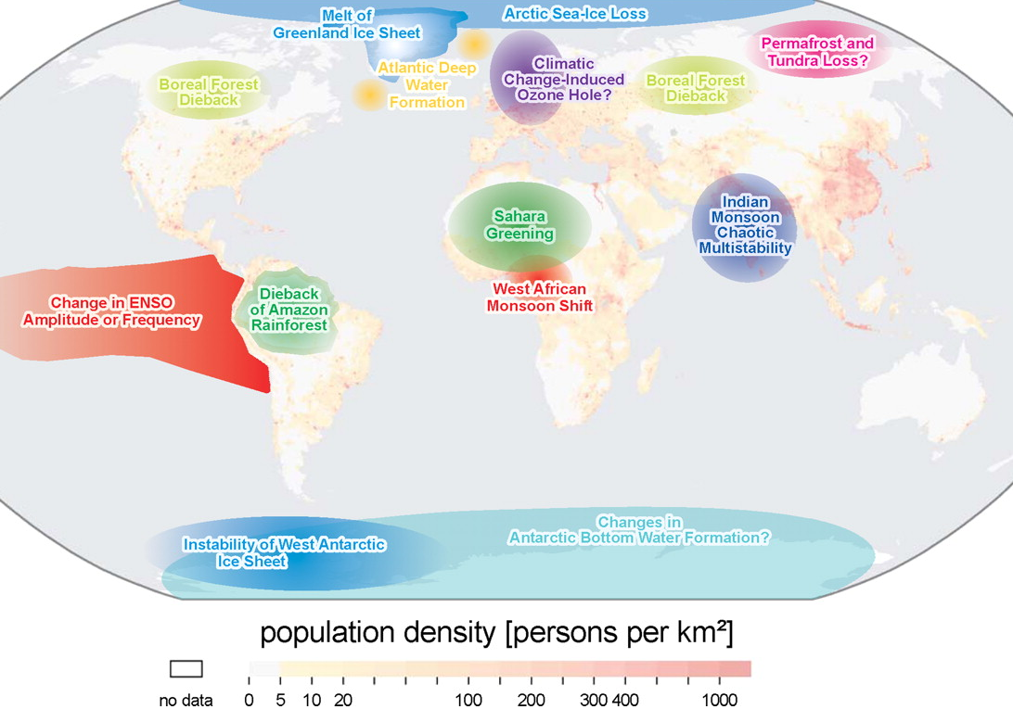

The theory behind tipping points is still unclear, as is their detection. However they are certainly worth monitoring and this is an area of active research.

1. **Some predictions of the future**

So, are we all doomed? It is not my job as a mathematician to say this one way or the other. However, I can urge everyone to be mindful of the effects of climate change. Despite what certain politicians may say, the evidence for human made climate change is very strong. This is supported by mathematical models which imply that unless we do act now the Earth’s temperature will continue to rise, and we can make clear predictions about how much that rise will be given the amount of Carbon Dioxide that we are releasing into the atmosphere. How we mitigate that rise, for example by using Carbon Capture Technology, or the use of renewable energy, is the subject of another lecture. But perhaps the main contribution that maths can make is, by using data and careful models, to take the hot air out of the climate debate. If you want to read more on this I strongly recommend the (free) book [10].

**References**

[1] The most recent IPCC report is given in <http://www.ipcc.ch/report/sr15/>

[2] The 2016 Paris Agreement is described in <https://en.wikipedia.org/wiki/Paris_Agreement>

[3] HRH The Prince of Wales, T. Juniper and E. Shuckburgh, (2017), *Climate Change*, Ladybird Books Ltd., London.

[4] The 5th IPCC assessment report is given in <http://www.ipcc.ch/report/ar5/>

[5] The website <http://wxcharts.eu> gives an excellent set of easy to follow, and up to date, weather charts.

[6] C. Budd, M. Cullen and C. Piccolo, (2016), ‘*Improving Weather Forecasting Accuracy by Using r-Adaptive Methods Coupled to Data Assimilation Algorithms,* in UK Success stories in Industrial Mathematics, Springer

[7] J. Imbrie and K. P. Imbrie, (1979). Ice ages: solving the mystery, Short Hills NJ: Enslow.

[8] H. Kaper and H. Engler, (2013), *Mathematics and climate*, SIAM

[9] T. Lenton, (2016), *Earth system science: a very short introduction*, Oxford

[10] D. Mackay (2015), *Sustainable energy without the hot air*, https://www.withouthotair.com/download.html

Chris Budd, 13th. November 2018